EEZ project – Check and build IEXT
The ESP has two options for checking and building an EEZ project as shown on Fig. 1. and Fig. 2.

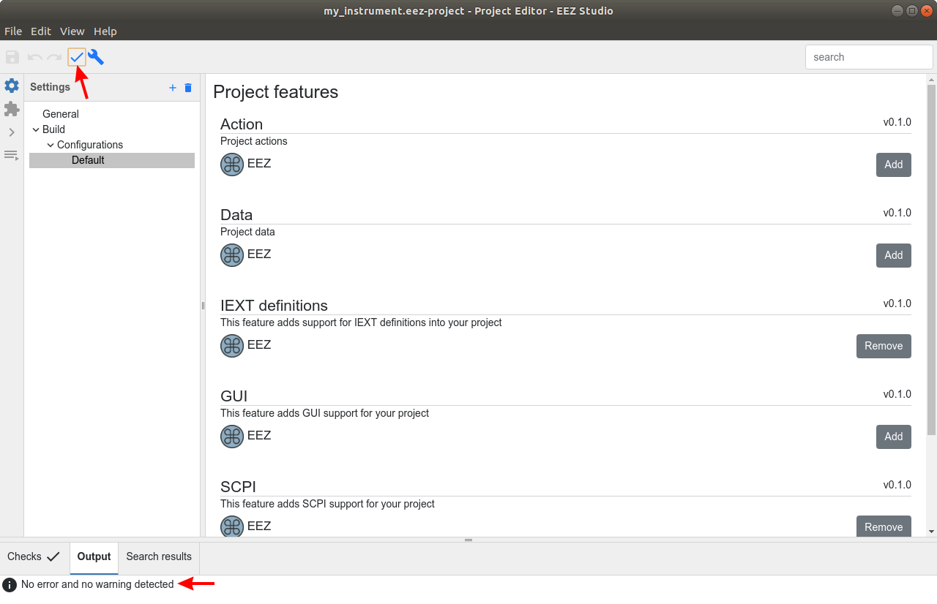Fig. 1: Project checking
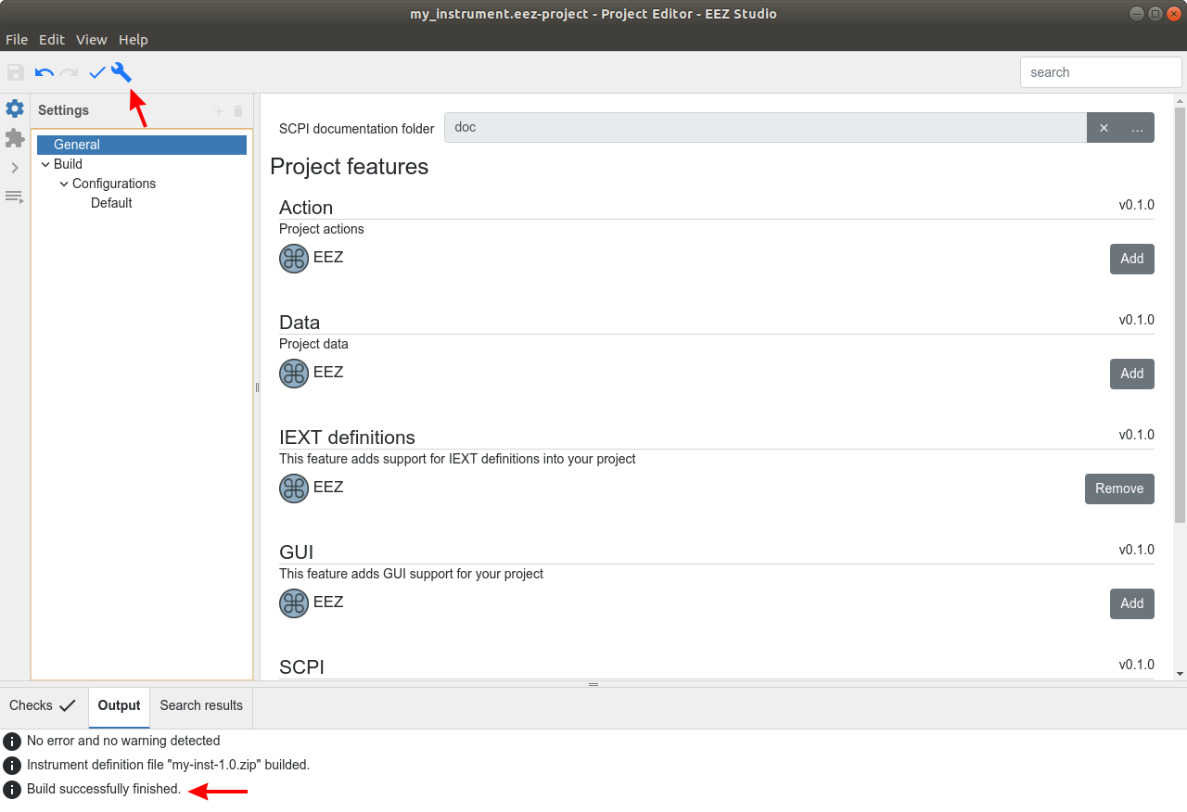Fig. 2: Project building
Build option will generate IEXP zip file in the same folder where project is located (Fig. 3.) and its suffix will include IDF revision number as described in Extension definitions section.

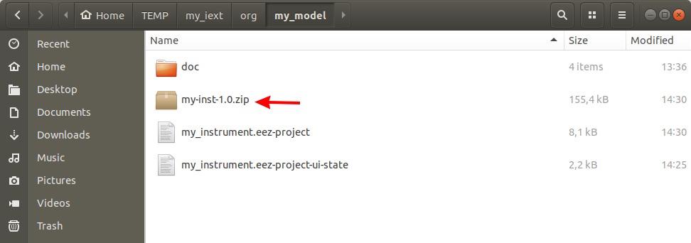Fig. 3: Generated IEXT zip file

Installing the new IEXT
Newly created IEXT can be immediately used in ESW module by installing it with selecting the Import Instrument Definition… option (Fig. 4.) and Import as Workbench extension (Fig. 5).

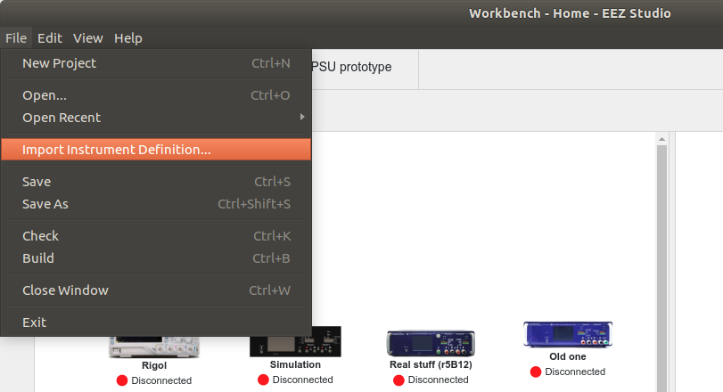Fig. 4: Import IEXT option
Successfully imported IEXT will become visible in Extension manager section as shown on Fig. 6.
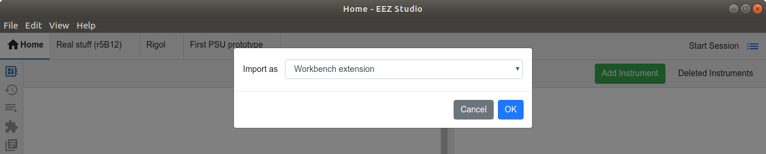Fig. 5: Import IEXT into ESW

Making the IEXT publicly available
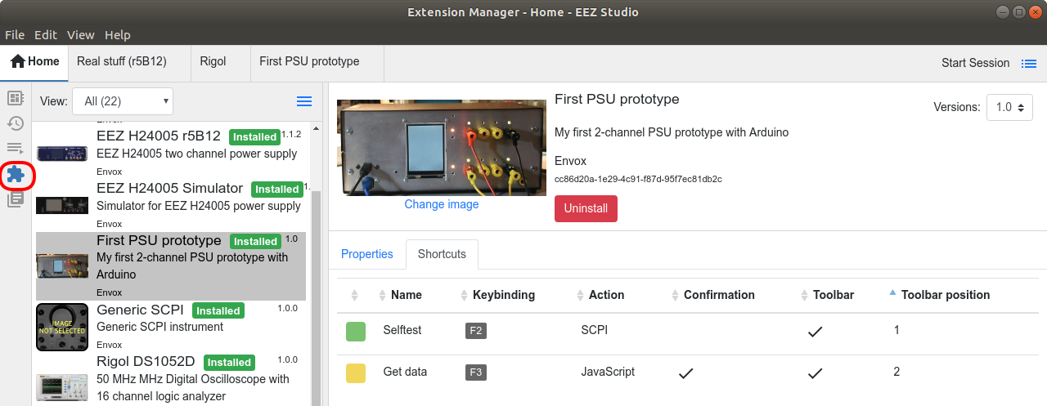Fig. 6: Newly installed IEXT in the Extension manager
The IEXT can be also made publicly available that other can use it with EEZ Studio. Other benefits in that case are better version control, network storage (i.e. GitHub repository) and easier installation when the ESW's Extension Manager Update catalog option can be used as described in Introduction.

The GitHub's pull request mechanism is used to make an IEXT publicly available by including it into the catalog of IEXT's that makes it accessible by the Extension Manager. A pull request for adding a new instrument extension (IEXT) should modify only ./extensions-list.txt (see IEXT repository section). The new IEXT could be hosted:
- locally (i.e. it will became a part of repository) or
- remotely as defined with given URL.
All locally hosted IEXT should be placed into /org/<manufacturer>/<instrument_folder>. The pull request have to be approved by EEZ team, and only files newly added into folder will be checked. The IEXT is also subject for a comprehensive inspection to ensure that it does not contain malicious code.

